NON TEACHING PROFILE
Name |  | S.Mathivanan |  |  |  | 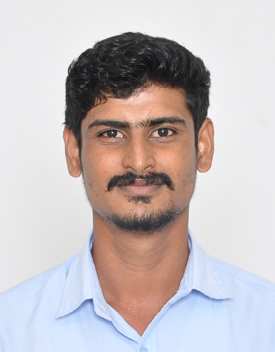
Department |  | Medical Electronics
Qualifications |  | D.Agri, B.Lit. Tamil
Area of Specialization |  | Medical Equipment
Date of Joining (VCET) |  | 01.07.2019
Date of Birth |  | 10.01.1996
Experience in (Years) |  | College | 3 Years | Industry
Number of Skill Up Gradation programme Attended | Academic Year |  | Workshop | Hands on Training | Mention if Any others
Contact Details | Email: |  | mathivananagrikingmathi@gmail.com
 | Mobile No: |  | 9360079985

