Faculty Profile
Name | Dr.V.CHANDRASEKARAN |  |  | 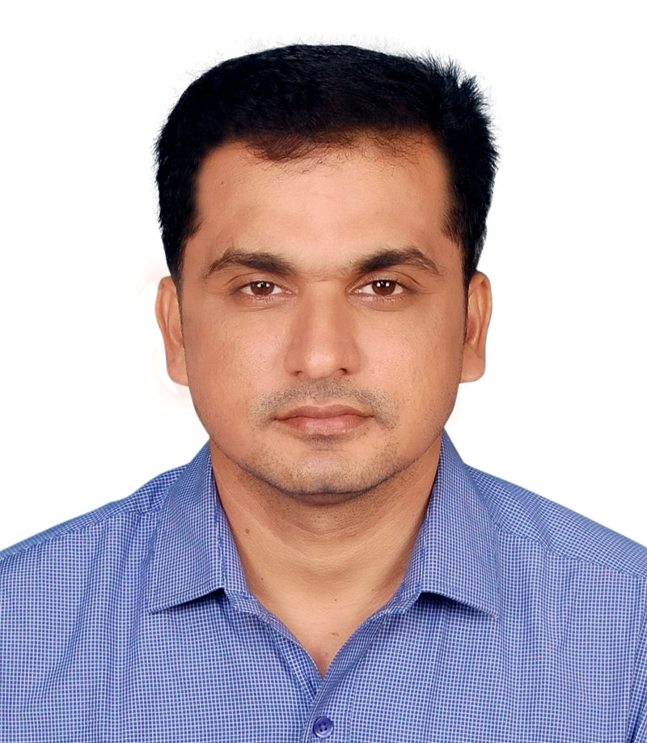
Department | MDE
Qualifications | B.E.,M.Tech.,PhD
Area of Specialization | Communication Systems and Signal Processing
Date of Joining (VCET) | 26.05.2006
Date of Birth | 30.05.1980
Experience in (Years) | Teaching | 19.6 | Industry |  | -
Number of Papers Published | National Journals | - | International  Journals |  | 17
Number of Papers Presented | National Conferences | 12 | International  Conferences |  | 7
Books Published | 1
Patents | Granted | - | Published |  | 3
Grants Received: | 2
Contact Details |  | vc4sachin@gmail.com
  Email:
 | Mobile | 98429 22355

