Faculty Profile
Name | INDHUMATHI K D |  |  | 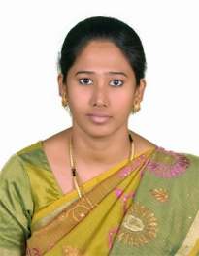  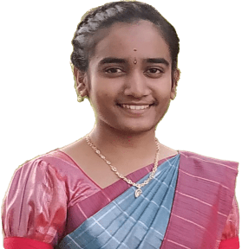
Department | MEDICAL ELECTRONICS
Qualifications | M.E.,
Area of Specialization | Biomedical Engineering
Date of Joining (VCET) | 05.07.2023
Date of Birth | 20.05.2000
Experience in (Years) | Teaching | - | Industry |  | -
Number of Papers Published | National Journals | - | International  Journals |  | -
Number of Papers Presented | National Conferences | - | International  Conferences |  | -
Books Published | -
Patents | Granted | - | Published |  | -
Grants Received: | -
Contact Details | Email: | inthumathi2020@gmail.com
 | Mobile | 9080506570

Others:
Youtube link

