Faculty Profile
Name | P.POORNIMA |  |  | 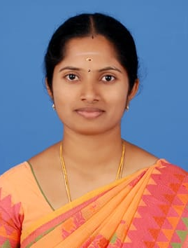
Department | MDE
Qualifications | M.E.,
Area of Specialization | VLSI DESIGN
Date of Joining (VCET) | 17.07.2020
Date of Birth | 21.01.1993
Experience in (Years) | Teaching | 3.8 | Industry |  | -
Number of Papers Published | National Journals | - | International  Journals |  | 2
Number of Papers Presented | National Conferences | - | International  Conferences |  | -
Books Published | -
Patents | Granted | - | Published |  | 1
Grants Received: | -
Contact Details | Email: | Poorni2111@gmail.com
 | Mobile | 6383133391

Others:

