Faculty Profile

Name | K.VANITHA |  |  | 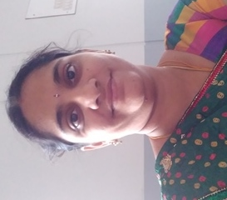
Department | Medical Electronics
Qualifications | B.E.,M.E.,
Area of Specialization | Computer and Communication Engineering
Date of Joining (VCET) | 17.07.2020
Date of Birth | 11.01.1987
Experience in (Years) | Teaching | 9.7 | Industry |  | -
Number of Papers Published | National Journals | - | International  Journals |  | 2
Number of Papers Presented | National Conferences | 2 | International  Conferences |  | 1
Books Published | -
Patents | Granted | - | Published |  | -
Grants Received: | -
Contact Details |  | vnthkrshnn@gmail.com
  Email:
 | Mobile | 9994139945

