Faculty Profile

Name | PRAKASH P |  |  | 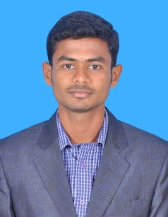
Department | Medical Electronics
Qualifications | M.E.,
Area of Specialization | Applied Electronics
Date of Joining (VCET) | 01.07.2019
Date of Birth | 27.10.1990
Experience in (Years) | Teaching | 6.2 | Industry |  | -
Number of Papers Published | National Journals | 02 | International  Journals |  | 01
Number of Papers Presented | National Conferences | 07 | International  Conferences |  | 05
Books Published | -
Patents | Granted | Nil | Published |  | 01
Grants Received: | Nil
Contact Details |  | psprakash7373@gmail.com
  Email:
 | Mobile | +91 9095062232

